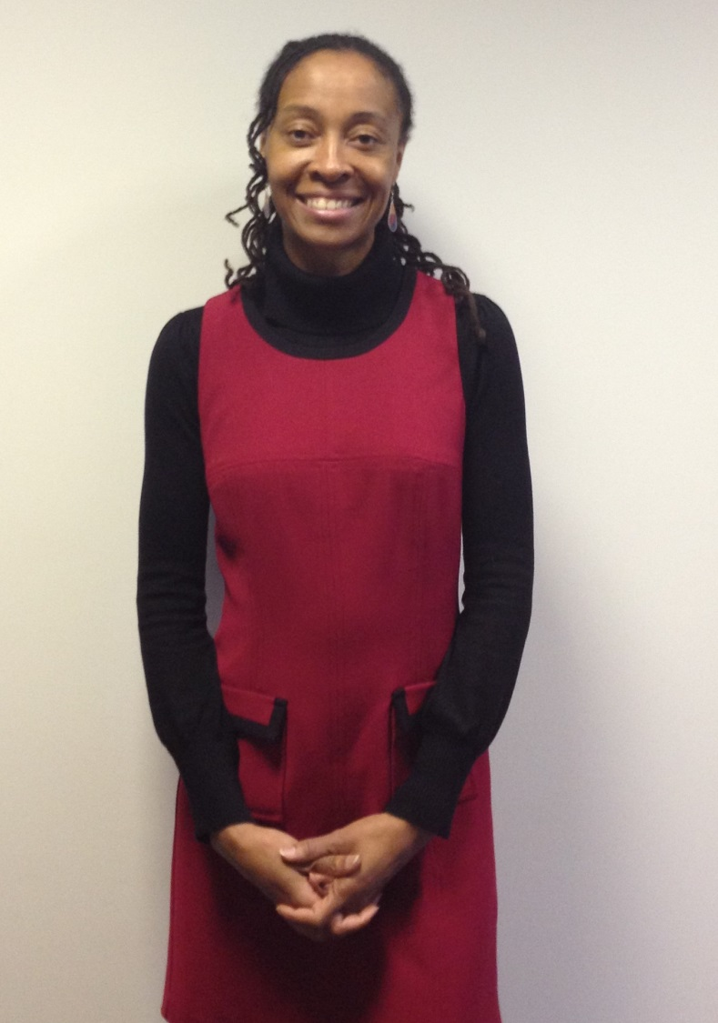
Claudine’s Story

I have been working as a trainee counselling psychologist with the team at Centre for Better Health for just over one year now. I am a 3rd (final) year student at City University and my course requires that I see clients in different settings. The Centre for Better Health was recommended to me by a colleague who recalled the good work done by its former incarnation: the psychiatric rehabilitation unit. I have found my time at Centre for Better Health quite rewarding in a number of ways.
I started my therapeutic training journey fourteen years ago at a volunteer crisis counselling helpline. I feel that my placement at the Centre for Better Health marks a return to working with an organisation with the ethos of making therapy accessible, especially to individuals in need who may not normally be able to access counselling.
It has been enlightening to work with counsellors training in a range of disciplines including Gestalt, Karuna and transactional therapy. My time here has been a learning experience in an unexpected way, as I have gained knowledge about different approaches to the range of challenges faced by clients attending the Centre. My clinical supervision sessions have been greatly enhanced by these different perspectives.
For various reasons, it appears many counselling services are only able to offer short term therapy to clients. While this is adequate for many, there are others who require a longer period of time to address their difficulties. It has been valuable experience to have the opportunity to work with clients for such an extended period of time, up to a year.
Whilst working as a volunteer counsellor, I have completed one of the numerous courses offered at Centre for Better Health. I found mindfulness based stress reduction very helpful given the stressful life of a working student! I’ve also been introduced to shiatsu by way of a taster session. This was a great way to find out about a physical therapy which I’ve never had the chance to try before. Whether you are a therapist in training looking for a placement with a difference and/or seeking to improve your well-being, I encourage you to explore what Centre for Better Health has to offer.

