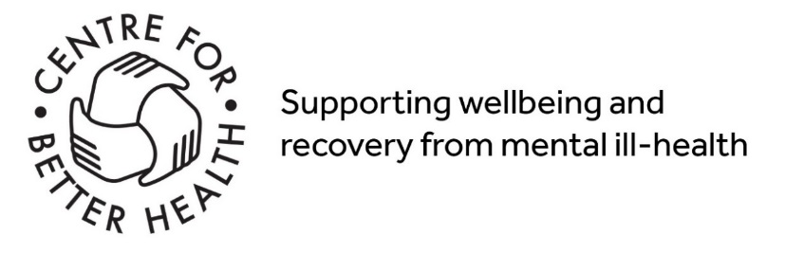

Please complete all sections:
*Mandatory fields.
Please fill in all questions with an *
Contact details:
*Title: ______
*First name: _______________________ *Surname/family Name: _______________________
During the process of accessing Wellbeing services, we will need to contact you by telephone.
*If we are unable to get through, are you happy for us to:
We will need to contact you to complete the screening and arrange assessments to complete this application.
Leave a voicemail | Yes | No
Send an email | Yes | No
*Contact number: ___________________________________
*Email address: ____________________________________________________________
*Address: ____________________________________________________________
City: _____________________________ *Postcode: ________________________
*Date of birth: ____________________________________
Any accessibility requirements: ______________________________________________
Please note that access to the Hub there is a small flight of stairs
Is an interpreter required: Yes / No If yes, please indicate for which language _______________________________________
*Name of your GP practice? (Compulsory) ______________________________
*An emergency Contact Name :________________________________ Ph Number: ________________________
ARE YOU PLANNING ON ENROLLING ON A COURSE/S (max of 2)
If yes, which one/s ________________________________________________________________________________
*In order to provide you with best possible support, we may need to share information.
While you are accessing the Wellbeing Network we will share information you provide internally and with City & Hackney Mind to ensure you are getting the most appropriate support. It is not possible to join the network without consenting to this. Please tick the box to indicate your consent to this Yes No
If you ticked no, we will not be able to proceed with your application at this time.
Demographic information:
Gender
Male | Prefer to self-describe
Female | Self described gender:…………………………………..
Prefer not to say | Do you identify as trans? Yes No
What is your ethnic category? What is your sexual orientation?
 | White or white British |  | Bisexual
 | Asian or Asian British |  | Gay woman/lesbian
 | Black or Black British |  | Gay man
 | Mixed background |  | Heterosexual
 | Other ethnic group |  | Other
 |  |  | Prefer not to say
What is your religion?
 | Atheist/no religion |  | Muslim
 | Buddhist |  | Secular beliefs
 | Chanedi |  | Sikh
 | Christian |  | Other
 | Hindu |  | Prefer not to say
 | Jewish
What is your current employment / unemployment status?
 | Employed full time (16+ hours) |  | If Unemployed, what is your status?
 | Employed part time |  | Looking for and available to start work
 | Self-employed full time(16+ hours) |  | Long term sick or disabled
 | Self-employed p/time |  | Retired
 | In education/training |  | Parent
 | Prefer not to say |  | Carer
 |  |  | Prefer not to say
What is your current Benefits status?
 | Claiming Benefits (inc. Tax credits or Council Tax Credit) | Not Claiming Benefits |  | Prefer not to say
What is your current accommodation status?
 | Owner occupier | Renting from housing association |  | Secure psychiatric unit
 | Renting from private landlord | Supported accommodation
 | Renting from local authority | NHS acute psychiatric ward |  | Homeless
 | living with family |  | Placed in temporary accommodation by Council
 | Other | Prefer not to say

Do you consider yourself to have a disability? | Yes | No | Prefer not to say
If yes, please provide details:

Do you have any dependent children? | Yes | No | Prefer not to say
Do you have any children under two? | Yes | No | Prefer not to say
Are you currently pregnant? | Yes | No | Prefer not to say
Do you currently smoke? | Yes | No | Prefer not to say
Are you a carer? | Yes | No | Prefer not to say
Do you have any allergies? | Yes | No | Prefer not to say

*Information about your support requirements
What current issues are you having that you need help with? Please provide a brief description: (Compulsory)
For example do you have depression / anxiety / or are you socially isolated etc. Providing us information will help with us with regard to the support we may be able to offer on the network. Also, please indicate courses you feel you may benefit from joining

Are you currently receiving any support from the following?
A Charity
NHS service
Council service
School / College / University
Privately paid service

We can offer support or refer you to organisations that may provide you support in the following areas
Please choose as many options as you need
Support around mental health and wellbeing
Support from others who have experienced mental health problems
Support to cope with grief or loss
Support to improve confidence
Support to understand / manage anger or aggression
Support to understand / manage anxiety
Support to understand / manage depression
Support to understand / manage difficult thoughts
Support to understand / manage low mood
Support to understand / manage stress
Support around a physically healthy lifestyle
Help managing the effects of long term illness
Information/ activities on healthy eating/ nutrition
Information/ activities to be more active/ improve fitness
Information/ activities to help with sleeping problems
Information on quitting smoking
Support around social networks and relationships
Information about community activities
Support to meet new people
Understanding my relationships
Support around managing routine and everyday life
Information around managing money
Making and sustaining changes
Tools to build a routine
Support around employment
Help gaining qualifications
Help getting a job
Managing workplace difficulties and stress
Support to become a volunteer
Support with learning and education
Computers/ IT English/ Literacy ESOL (English as second language) Maths

Filling out the following questionnaires will help us to determine the right kind of support for you on the network.
Over the past week, how often have you bothered by any of the following problems? | 0 – Not at all | 1 – Several days | 2 – More than half the days | 3 – Nearly every day
Little interest or pleasure in doing things
Feeling down, depressed, or hopeless
Trouble falling or staying asleep, or sleeping too much
Feeling tired or having little energy
Poor appetite or overeating
Feeling bad about yourself – or that you are a failure or have let yourself or your family down
Trouble concentrating on things, such as reading or watching television
Moving or speaking so slowly that other people could have noticed, or the opposite – being so fidgety or restless that you have been moving around a lot more than usual
Thoughts that you would be better or dead or hurting yourself in some way
Feeling nervous, anxious or on edge
Not being able to stop or control worrying
Worrying too much about different things
Trouble relaxing
Being so restless that it is hard to sit still
Becoming easily annoyed or irritable
Feeling afraid as if something awful might happen

Peoples problems sometimes affect their ability to do certain day-to-day tasks in their lives. To rate your problems look at each section and determine on the scale how much your problem impairs your ability to carry out the activity (‘0’ means not at all impaired and ‘8’ means very severely impaired) | 0 | 1 | 2 | 3 | 4 | 5 | 6 | 7 | 8
Because of my problem, my ability to work is impaired
Because of my problem, my home management (cleaning, tidying, shopping, cooking, paying bills, looking after home or children)
Because of my problem, my social leisure activities with other people (e.g parties, outings, dating, entertaining etc) are impaired
Because of my problem, my private leisure activities done alone, such as reading, gardening, sewing, or walking alone are impaired
Because of my problem, my ability to form and maintain close relationships with others, including those I live with, is impaired

In order to complete to the application, you may need to have a short telephone call with our Wellbeing coordinator for a risk assessment screening. This should take no more that 5-10 minutes.
Thank you !

