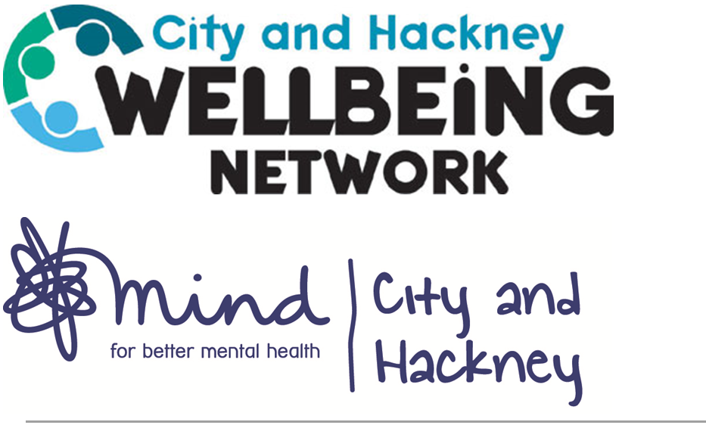
Please complete all sections:
Contact details:
Title:
First name (client): Surname/family Name:
Information about your support requirements
What current issues are you having that you need help with?
Brief description:

Have you enrolled on a course?
Name of course:
Please choose the options that best describe the areas that you would like support with. These are optional and you can choose as many as you need.
I’d like to improve my wellbeing
Creative activities |  |  | Daily routine and motivation
Isolation and loneliness |  |  | Peer-support
Self-esteem |  |  | Stress management
Transition/change difficulties
I’d like support with low mood and/or anxiety
Anxiety |  |  | Depression
Emotional difficulties |  |  | Hopelessness
Low mood
I’d like support around relationships and identity
Abortion/miscarriage/fertility |  |  | Bullying
Cultural issues |  |  | Divorce and separation
Domestic violence |  |  | Family problems
Gender identity |  |  | Grief/loss/bereavement
Identity |  |  | Parenting
Peer support |  |  | Postnatal depression
Relationship break-up |  |  | Relationship problems
Sexual dysfunction |  |  | Sexuality
Social isolation/loneliness |  |  | Transition/change/stage of life
I’d like support with my mental health
Abuse |  |  | Aggression
Agoraphobia |  |  | Anger
Anxiety |  |  | Binge Eating
Bi-polar disorder |  |  | Bulimia
Childhood abuse |  |  | Depression
Drug/alcohol addiction |  |  | Gambling
Gender dysphoria |  |  | Internet addiction
Managing mental health condition |  |  | Obsessions/compulsions/OCD
Panic Attacks |  |  | Personality disorder
Phobia |  |  | PTSD
Post Natal Depression |  |  | Psychosis
Psychosomatic complaints |  |  | Self-harm
Sexual dysfunction |  |  | Sleeping problems/insomnia
Social anxiety/Phobia |  |  | Suicidal thoughts
Support recovering from a crisis |  |  | Trauma
Unexplained medical symptoms |  |  | Victim of crime/assault
Victim of torture/persecution/war
I’d like support with physical health
Be more active/improve fitness |  |  | Healthy eating/nutrition
Ill-health |  |  | Long-term illness/chronic condition
Quit smoking |  |  | Sleeping problems
Unexplained medical symptoms |  |  | Weight loss
I’d like support with managing routine and everyday life
Cooking |  |  | Managing money
Motivation and routine
I’d like support with employment
Coming out at work |  |  | Help getting a job
Redundancy and employment |  |  | Support to become a volunteer
Workplace difficulties and stress |  |  | Worried I might lose my job
I’d like support with learning and adult education
Computer/ IT |  |  | English/Literacy
ESOL (English) |  |  | Maths

I’d like support speaking up and accessing services
I’d like support with finances and benefits

Contact details:
In order to be accepted on the Network, we will need to contact you by telephone to complete this referral.
Kindly indicate when would be the best day(s)/time(s) to call you:
 | Monday | Wednesday | Thursday
AM (9-1pm)
PM (1-5pm)

If we are unable to get through, are you happy for us to:
Leave a voicemail | Yes | No
Send an email | Yes | No

Contact number:
Email address:
Address:

City: Postcode:
Date of birth:
Is an interpreter required: yes / no
What is the name of your GP practice? (Compulsory)

Diversity information:
Gender: What is your marital status?
Man |  | cohabiting
Woman |  | Divorced
Transgender Man |  | Lone parent
Transgender Woman |  | Married/civil partnership
Prefer not to say |  | Partner
Other |  | Separated
 |  | Single
 |  | widowed
 |  | Prefer not to say

What is your ethnic category? What is your sexual orientation?
White or white British |  | Bisexual
Asian or Asian British |  | Gay woman/lesbian
Black or Black British |  | Gay man
Mixed background |  | Heterosexual
Other ethnic group |  | Other
Prefer not to say |  | Prefer not to say

What is your religion?
Atheist/no religious belief |  | Muslim
Buddhist |  | Secular beliefs
Chanedi |  | Sikh
Christian |  | Other
Hindu |  | Prefer not to say
Jewish

What is your current employment status?
Receiving benefits |  | Self-employed part time
Employed full time |  | Self-employed full time
Employed part time |  | Retired
In education/training |  | Unemployed
Long term sick or disabled |  | Unemployed and available for work

What is your current accommodation status?
Owner occupier |  | Shared ownership
Rented from Hackney Council |  | A residential home
Temporary accommodation  Placed by Hackney council |  | Homeless
Rented from registered provider such as Housing Association |  | NHS acute psychiatric ward  Other NHS facilities,  Hospital
Rented from private landlord |  | Other Prefer not to say

Thank you for taking the time to complete this form, we will now forward this information to The City and Hackney Wellbeing Network. You will receive a phone call from a coordinator to take you through the rest of your application process.

Signed: …………………………………………………………. Dated: ……………………..

